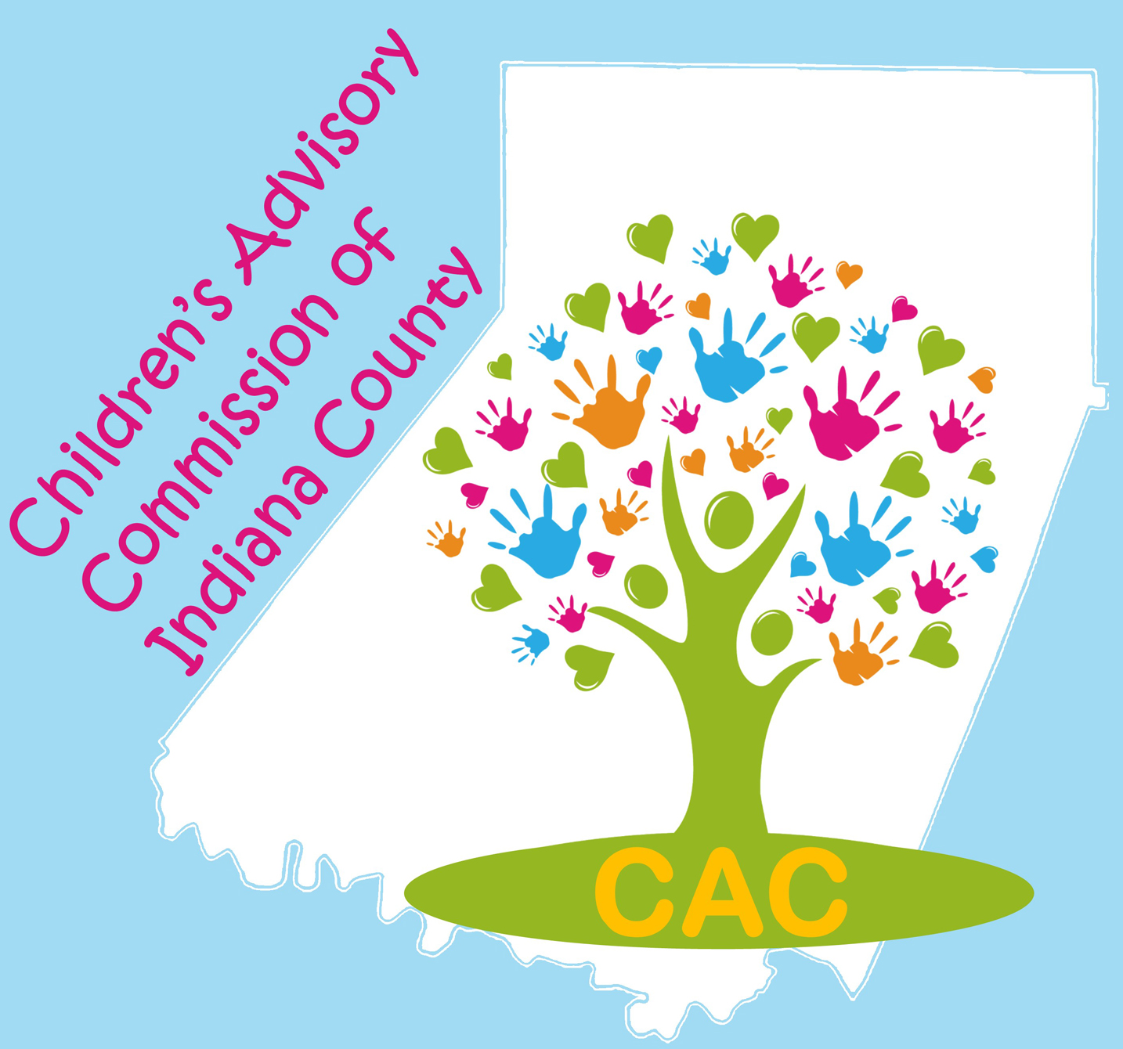
The Children’s Advisory Commission of Indiana County
Mission: Seeking to improve outcomes for children, adolescents, and their families in Indiana County.

AGENDA: Tuesday, December 1, 2020

CAC 2020-2021 Officers:
Co-Chairs:
Carol Schurman
Laura McLaine

Co-Secretaries:
Lindsey Jones
Roxie Johnston

Treasurer: Marti Higgins

Immediate Past Co-Chair: Jill DaBella

Upcoming Committee Meeting Dates:

CAC Executive: Tuesday, Dec. 15th, 9AM @ ICDHS/Zoom

Safe Children’s Network, Tuesday, Jan. 26th, 8:30 AM @Eat ‘N Park and Zoom

ECEC, At this time, rolled in with CAC meetings via Zoom

Upcoming Events and Fundraisers:

Gardner’s Candy 100% Online Fundraising to benefit CAC! Order until December 21st!

Go to:
https://www.gardnerscandiesfundraising.com/
Group ID #10-2662

Time: 8:30 AM Location: ZOOM Join Zoom Meeting

The CAC Executive Committee met on October 20, 2020 to set the agenda for today.

8:30AM Call to Order and Roll Call: Carol Schurman/Laura McLaine

Reading, correction and approval of the November, 2020 meeting.

Motion to accept the minutes: _________________ Second: ____________________

Budget and Finance Committee:
Gardner’s Candy 100% Online Fundraiser

Total Balance: $__________CAC portion: $__________ Safe Children portion: $____________

Motion to accept the Financial Report: _________________ Second: _____________________
Updates from CAC Committees/Members
  - Early Care & Education –
    - Kathy Abbey-Baker – Fun Fest 2021
    - Sue Good (ELRC)
  - Strategic Planning – No report
  - Policy –
    - Election of CAC Co-Chair and Co Secretary
    - Upcoming Bylaws Review meeting
  - Safe Children – Sue Good
  - Teen Takeover – No report
  - New Member Applications: None

Developing and enhancing communications and collaboration:

Pre-Presentation Activity: Charlie-in-the-Box

Special Presentations: Conversations on Inclusion, 2020

- Overview of the Arc of Indiana County Programs – Michelle Jordan
- The Miracle League – Paula Leib
- Center for Independent Living of South Central PA – Marty Dombrowsky

Announcements, sharing, agency updates:
Adjournment
NEXT MEETING: Tuesday, January 5, 202, 8:30 AM via Zoom

