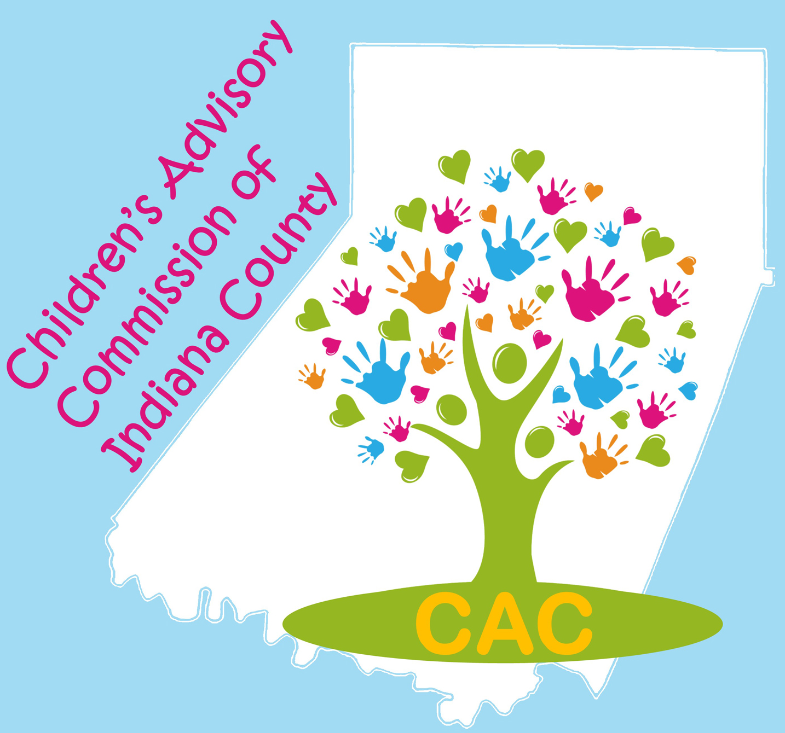
The Children’s Advisory Commission of Indiana County
Mission: Seeking to improve outcomes for children, adolescents, and their families in Indiana County.

AGENDA: Tuesday, January 7, 2020

CAC 2020-2021 Officers:
Co-Chairs:
Carol Schurman
Laura McLaine

Co-Secretaries:
Lindsey Jones
Roxie Johnston

Treasurer: Marti Higgins

Immediate Past Co-Chair: Jill DaBella

Upcoming Committee Meeting Dates:

ECEC: Tuesday, January 14th , 9AM @ ICDHS

CAC Executive: Tuesday, January 21st, 9AM @ ICDHS

Safe Children’s Network, Tuesday, January 28th, 8:30 AM @Eat ‘N Park

Upcoming Events and Fundraisers:

Registration Link for tables at the February 29, 2020, 17th Annual Family Fun Fest (LEAP) is on the CAC Event page:
CACfamilyEvents.com

Fingerprinting Services change. ARIN IU no longer offers this service. You can go to www.identogo.com and click “Locations,” enter your zip code to find the closest location to you.

Location: HOSS’s Restaurant Time: Noon

The CAC Executive Committee met on December 17, 2019 to set the agenda for today.

12:15 – Lunch orders will be taken. Don’t forget your Cash Cow card or email for the CAC fundraiser.

8:30AM Call to Order, Carol Schurman/Laura McLaine

Introductions: Re-Gifting Activity. Introduce yourself, and give a brief explanation of your unwanted gift. Complete your assigned “task” to re-gift your gift.

Meet & Eat
Reading, correction and approval of the minutes from the December meeting during lunch.

Motion to accept the minutes: _________________ Second: ____________________

Budget and Finance Committee:

Total Balance: $__________CAC portion: $__________ Safe Children portion: $____________

Motion to accept the Financial Report: _________________ Second: _____________________
Updates from CAC Committees
  - Early Care & Education – Kathy Abbey-Baker
  - Family Fun Fest Planning – Planning Committee members present
  - Strategic Planning – No report
  - Policy – No report
  - Safe Children – Sue Good
  - Teen Takeover- On hiatus, will be regrouping in 2020

Developing and enhancing communications and collaboration:

Special Presentation:

New Year’s Resolutions: Good news and bad news

- New Member Applications none

Announcements:

Adjournment
NEXT MEETING: Tuesday, February 4, 8:30 AM at ARIN IU28

