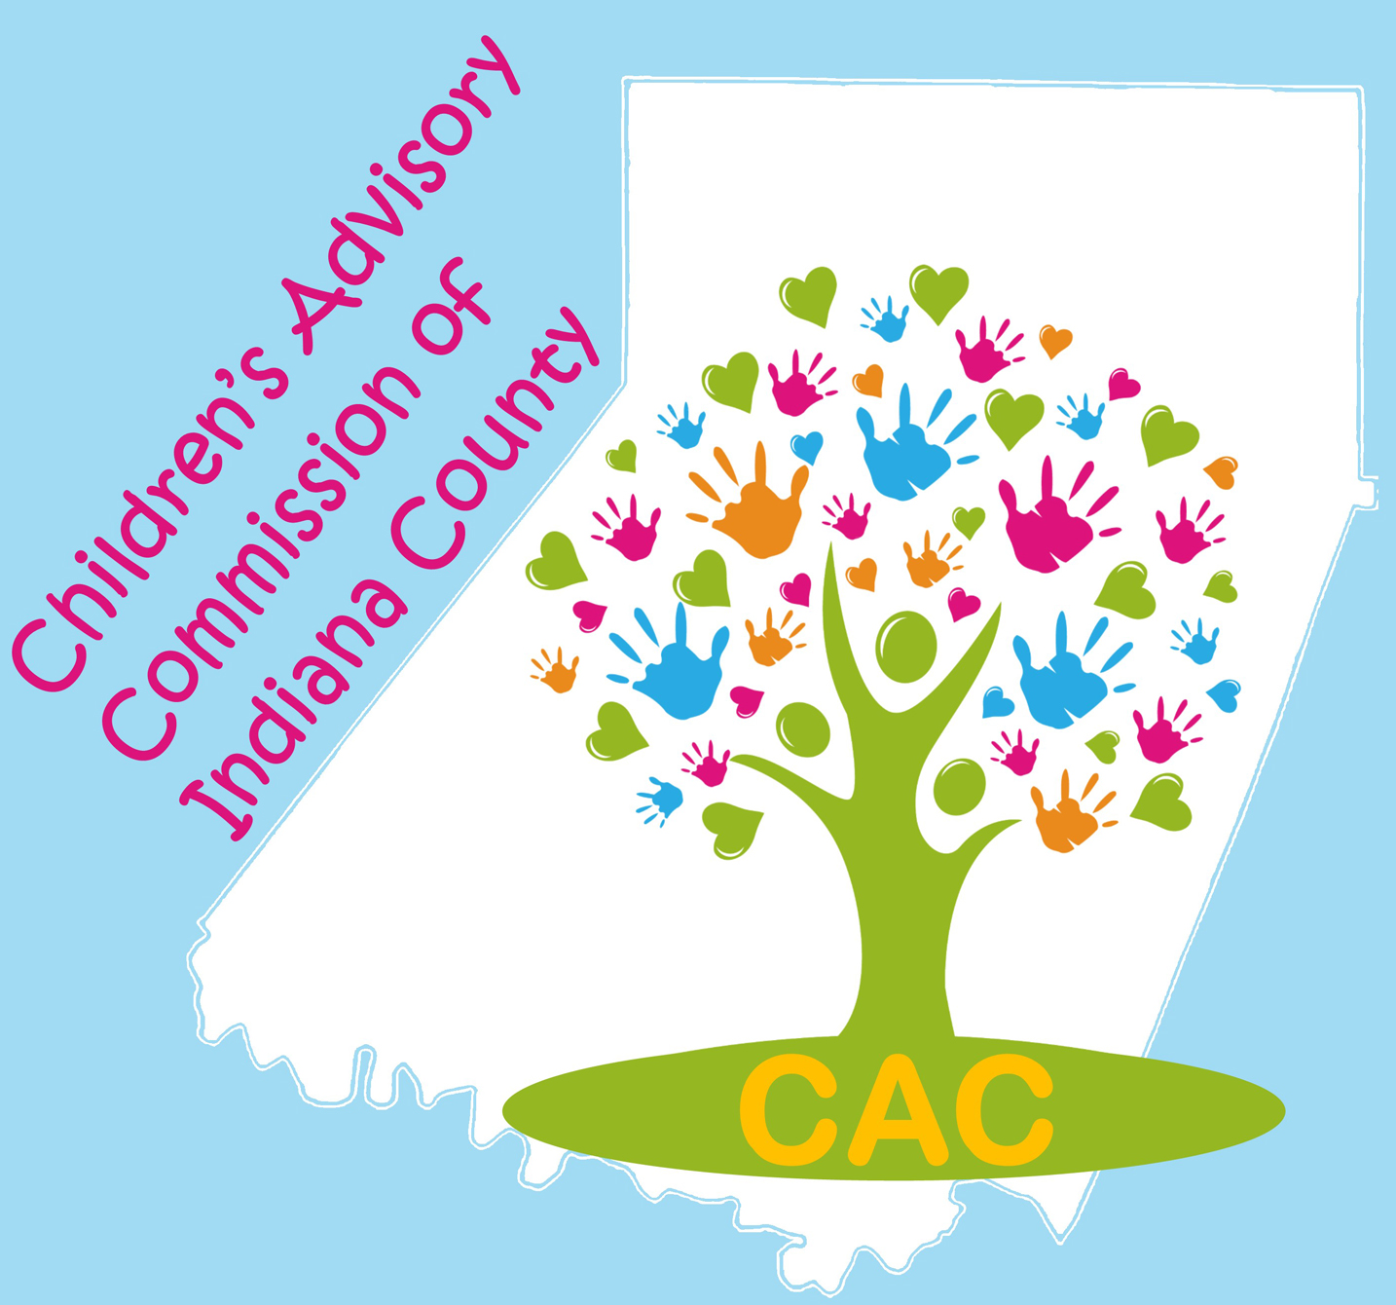
The Children’s Advisory Commission of Indiana County
Mission: Seeking to improve outcomes for children, adolescents, and their families in Indiana County.

AGENDA: Tuesday, February 4, 2020

CAC 2020-2021 Officers:
Co-Chairs:
Carol Schurman
Laura McLaine

Co-Secretaries:
Lindsey Jones
Roxie Johnston

Treasurer: Marti Higgins

Immediate Past Co-Chair: Jill DaBella

Upcoming Committee Meeting Dates:

Fun Fest Planning, Tuesday February 11th, 11AM @ Mall, New Life Cafe

CAC Executive: Tuesday, February 18th, 9AM @ ICDHS

Safe Children’s Network, Tuesday, February 25th, 8:30 AM @Eat ‘N Park

ECEC, Tuesday, April 14th, 9AM @ Indiana Free Library

Upcoming Events and Fundraisers:

Suicide Task Force, Chipotle Fundraiser, Wednesday February 5th between 5-9 PM. Mention Suicide Task Force of Indiana County to the cashier so STF can receive 33% of the proceeds.

Family Fun Fest! Saturday, February 29, 2020. LEAP with us!

Please help spread the work. Posters available for your office and postcards available for the families you serve.

If you are available to volunteer, please contact Maureen Pounds at mpounds@indianacountypa.gov

Location: ARIN IU 28 Time: 8:30 AM

The CAC Executive Committee met on January 21, 2020 to set the agenda for today.

8:30AM Call to Order and Welcome: Carol Schurman/Laura McLaine

Introductions: Tell us your name, your agency, and your generation.

Brief Generational Ice Breaker: Partner up with someone from a different generation, and talk about the topic on your generation ID card.

Business Meeting:

Reading, correction and approval of the minutes from the January 2020 meeting.

Motion to accept the minutes: _________________ Second: ____________________

Budget and Finance Committee:

Total Balance: $__________CAC portion: $__________ Safe Children portion: $____________

Motion to accept the Financial Report: _________________ Second: _____________________
Updates from CAC Committees
  - Early Care & Education – Kathy Abbey-Baker
  - Family Fun Fest Planning – Planning Committee members present
  - Strategic Planning – No report
  - Policy – No report
  - Safe Children – Sue Good
  - Teen Takeover- On hiatus, will be regrouping in 2020

Developing and enhancing communications and collaboration:

Special Presentations:

- Career Link Programs presented by Lenore Hughes and Jim Garland
- TED TALK: Generational Stereotypes
- New Member Applications: Corrine Putt

Announcements:

Adjournment
NEXT MEETING: Tuesday, March 3, 2020. 8:30 AM at ARIN IU28

