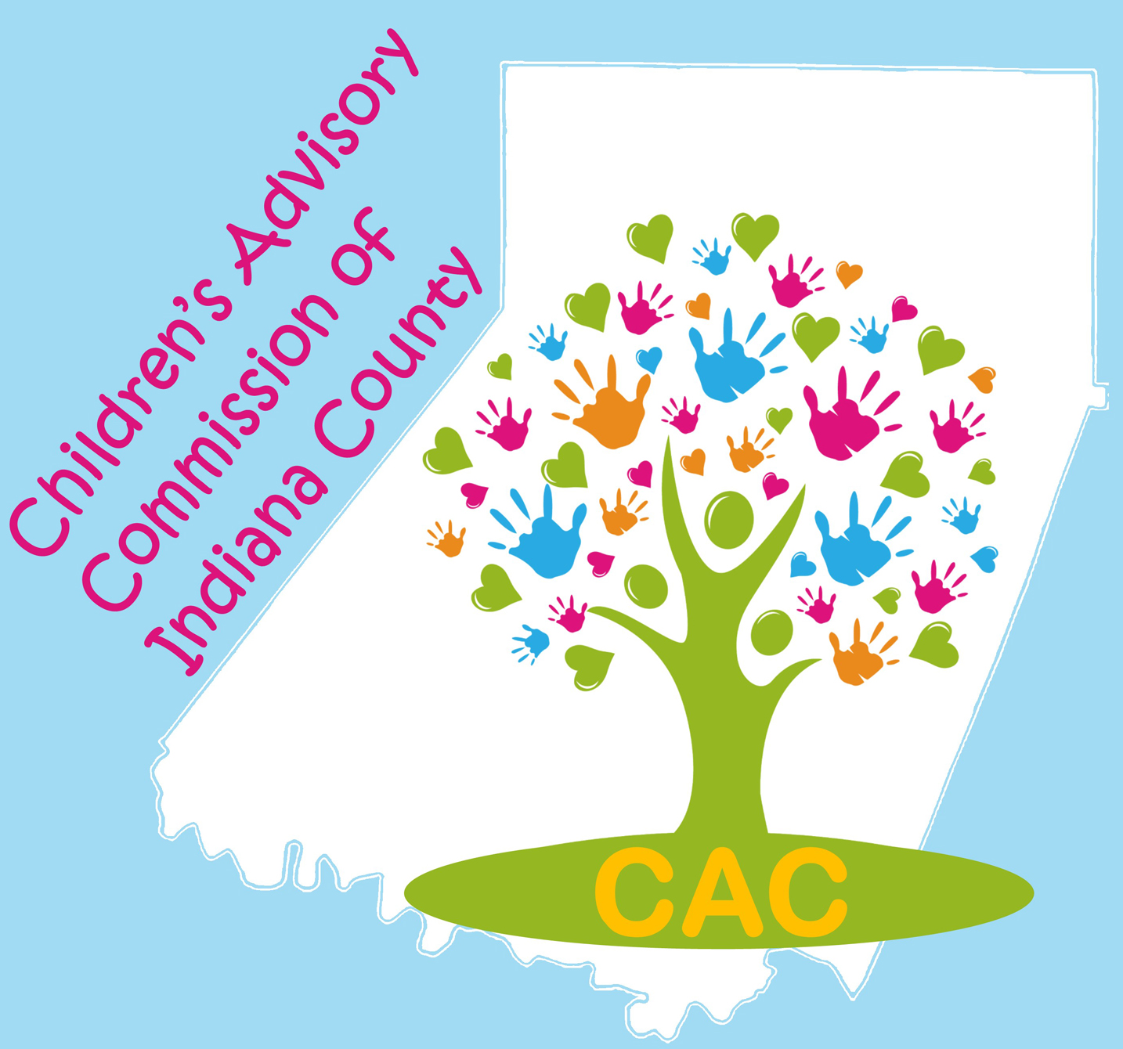
The Children’s Advisory Commission of Indiana County
Mission: Seeking to improve outcomes for children, adolescents, and their families in Indiana County.

AGENDA: Tuesday, March 3, 2020

CAC 2020-2021 Officers:
Co-Chairs:
Carol Schurman
Laura McLaine

Co-Secretaries:
Lindsey Jones
Roxie Johnston

Treasurer: Marti Higgins

Immediate Past Co-Chair: Jill DaBella

Upcoming Committee Meeting Dates:

Fun Fest Wrap-Up TBA

CAC Executive: Tuesday, March 17th, 9AM @ ICDHS

Safe Children’s Network, Tuesday, March 24th, 8:30 AM @Eat ‘N Park

ECEC, Tuesday, April 14th, 9AM @ Indiana Free Library

Upcoming Events and Fundraisers:

Safe Day at the Indiana Mall, March 28th, 10-1 at the Indiana Mall, sponsored by the Arc of Indiana County

Empty Bowls Fundraiser
Benefits ICCAP Food Bank. March 18th
11 am to 2 pm
F.O.E., 420 Philadelphia Street, Indiana.Take out available.

Location: ARIN IU 28 Time: 8:30 AM

The CAC Executive Committee met on February 21, 2020 to set the agenda for today.

8:30AM Call to Order and Introductions: Carol Schurman/Laura McLaine

Reading, correction and approval of the minutes from the February, 2020 meeting.

Motion to accept the minutes: _________________ Second: ____________________

Budget and Finance Committee:

Total Balance: $__________CAC portion: $__________ Safe Children portion: $____________

Motion to accept the Financial Report: _________________ Second: _____________________

Fundraising: Divine Dip Fundraiser Redux!
Updates from CAC Committees
  - Early Care & Education –
    - Family Fun Fest Event
  - Strategic Planning – No report
  - Policy – No report
  - Safe Children – Sue Good
  - Teen Takeover – No report

Developing and enhancing communications and collaboration:

Special Presentations:

- This is Us Survey Results

- TED TALK: Elizabeth Dunn - Helping others makes us happier… but it matters how we do it. Research shows that helping others makes us happier. But in her groundbreaking work on generosity and joy, social psychologist Elizabeth Dunn found that there's a catch: it matters how we help. Learn how we can make a greater impact -- and boost our own happiness along the way -- if we make one key shift in how we help others. "Let's stop thinking about giving as just this moral obligation and start thinking of it as a source of pleasure," Dunn says.

- New Member Applications: None this month

Announcements:

Adjournment
NEXT MEETING: Tuesday, April 7, 2020. 8:30 AM at ARIN IU28. Safe Children Breakfast Fundraiser: $7 donation

