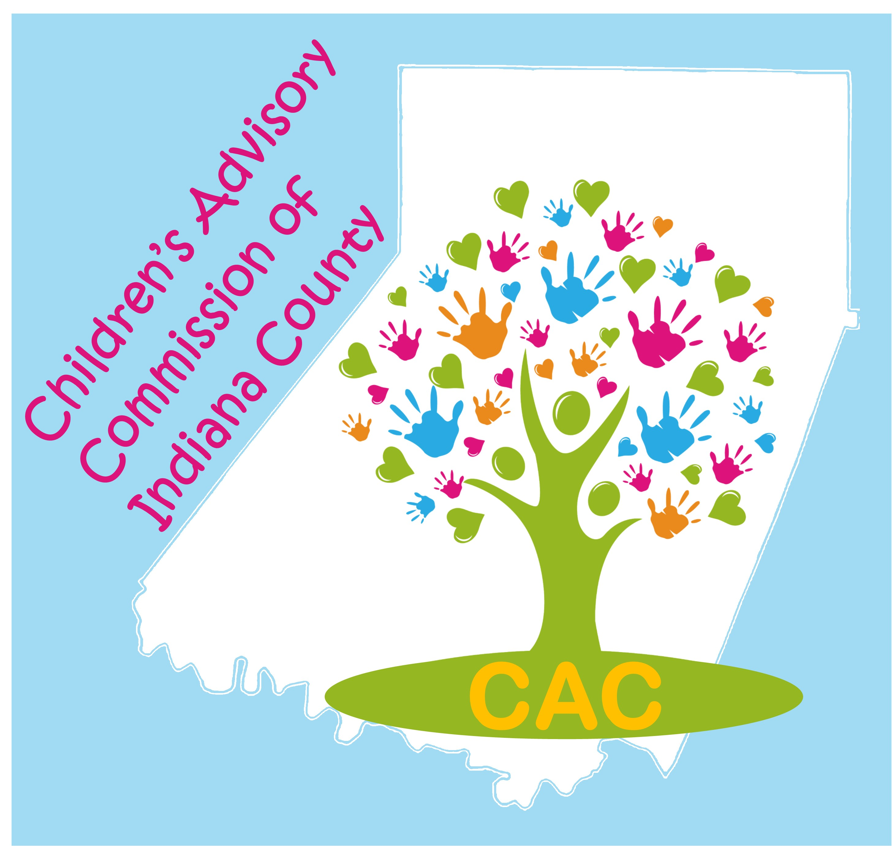

Voluntary Membership Donation – 2020 INVOICE

The Children’s Advisory Commission of Indiana County requests that members and sub-committee members contribute an annual donation to help defray the expenses of the Commission that are not covered by grant and other fundraising monies.

Name: ________________________________________________________________________

Agency: ______________________________________________________________________

Phone: ___________________ E-Mail: _________________________________________

Suggested Donation Levels:

Member Agency Level: $50.

Community/Individual Member Level: $35.

“Other” amounts are accepted as well!
- AMOUNT ENCLOSED:

Agency Level $50 _______

Community Level $35 ________

Or

Other $____________

Do you want your contribution publicly acknowledged on the CAC website and at community events? _____ Yes _____ No

Make check payable to “CAC”

Mail to (or drop off):
CAC
C/O Indiana County Department of Human Services
300 Indian Springs Road, Suite 203
Indiana, PA 15701

ATTN: Lisa Spencer

www.CACfamilyEvents.com
www.childrensadvisorycommission,org
IndianaCountyCAC@yahoo.com
cac@indianacountypa.gov
724-463-8200 x 8

Thank you for your support!

