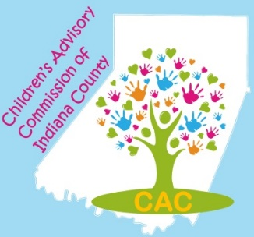
Mission: Seeking to improve outcomes for children, adolescents, and their families in Indiana County.

Value Statement: The Commission respects and values the contributions of each member, and seeks to build an inclusive and diverse membership and to honor diversity in the entire Indiana County community, fostering respect for all.
APPLICATION FOR MEMBERSHIP:

Name: ___________________________________________________Title: ______________________________________

Organization: ________________________________________________________________________________________

Organization web-site: _________________________________Facebook _______________________________________

Address: ___________________________________________________________________________________________

Phone: _____________________ E-Mail: ___________________________________________ Fax: __________________

Reason for interest in the CAC Board and experience or background related to children’s issues:

___________________________________________________________________________________________________

___________________________________________________________________________________________________

____________________________________________________________________________________________

____________________________________________________________________________________________

Commitment Agreement

- I understand that the CAC Board of Directors meets 11 times per year (No July meeting.) As a member, I will attend regularly scheduled meetings. I understand that if I miss three (3) consecutive meetings, without an excused absence, I could lose my seat on the Board.
- I agree to volunteer for at least one outreach event within each calendar year. (January – December.)
- I agree to participate, in some capacity, in at least one fundraiser within each calendar year.
- I agree to serve on at least one standing committee or event planning committee.
By checking this box, I agree to the above commitment criteria.

I am interested in serving on the following committee(s):

_____ Budget & Finance/Fundraising _____ Policy _____Early Care and Education

_____ Safe Children’s Network Event Planning: ___Day of Play ___Fun Fest ___ Nature Palooza

____________________________________________________ _____________________
Signature Date

Please return this application to:

CAC Coordinator Phone: 724-463-8200 extension 8
C/O Indiana County Department of Human Services Fax: 724-465-3159
300 Indian Springs Road, Suite 203 Email: CAC@indianacountypa.gov
Indiana PA, 15701 Web: www.ChildrensAdvisoryCommission.org
Please return application to:

CAC Coordinator
C/O Indiana County Department of Human Services
Courthouse Annex Building
827 Water Street – 2nd Floor
Indiana, PA 15701
Phone: 724-463-8200
Fax: 724-465-3159
Email: KABaker@yahoo.com
Web: www.IndianaCountyCAC.com
Please return application to:

CAC Coordinator
C/O Indiana County Department of Human Services
Courthouse Annex Building
827 Water Street – 2nd Floor
Indiana, PA 15701
Phone: 724-463-8200
Fax: 724-465-3159
Email: KABaker@yahoo.com
Web: www.IndianaCountyCAC.com
Please return application to:

CAC Coordinator
C/O Indiana County Department of Human Services
Courthouse Annex Building
827 Water Street – 2nd Floor
Indiana, PA 15701

